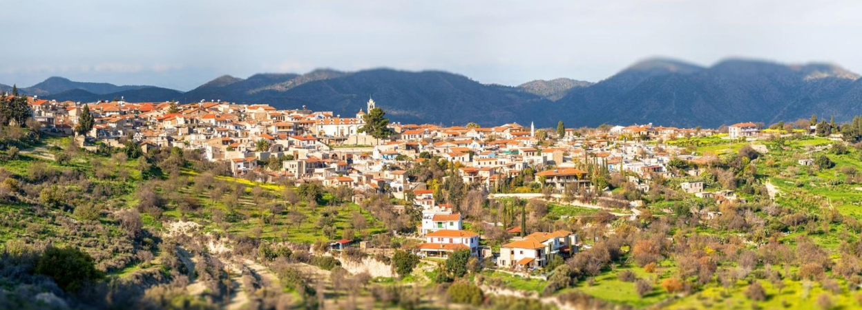

APPLICATION FORM

BIOSTARS Youth Innovators Call
Supporting the next generation of rural innovators

https://biostars.interreg-euro-med.eu

APPLICANT INFORMATION

1. Full name

2. Date of birth

3. Occupation

4. Email

5. Telephone number*

*Your address and telephone number will be used only for the management of the BIOSTARS Youth Innovators Call. These personal data will not be published or shared without your consent.
6. Country and address*
☐ Spain (Aljarafe-Doñana)
☐ Italy (Subequana Valley)
☐ Croatia (Lovas)
☐ Bosnia and Herzegovina (Hadžići)
☐ Greece (Amyntaio)
☐ Cyprus (Athienou)
Address*:

7. Are you applying as:
☐ Individual
☐ Team
Team members:

IDEA / PROJECT
Project title
Tell us about your project (max. 300 words)
Explanation: Give us a short overall summary of your project. Tell us briefly about yourself and your enterprise, describe what you plan to do and what you hope to produce or deliver. Using honest and plain language, explain what this would mean for your local community.
Which BIOSTARS priority area best fits your project?
☐ Rural innovation
☐ Bioeconomy
☐ Circular economy
☐ Green transition
☐ Renewable energy
☐ Sustainable food systems
☐ Nature-based solutions
☐ Digital innovation for rural areas in the frame of bioeconomy
☐ Social innovation
☐ Youth entrepreneurship

Current stage

☐ Idea

☐ Prototype

☐ Early-stage project

☐ Business / initiative (up to two years old)

Explain the main challenge or need your project addresses. Why is this an important issue for your rural community? (max150 words)

Explanation: In practical terms, what will your project actually do or produce? (For example: a new food product, a service, better use of local materials, reduced waste, or a new income stream for you and others.) Be specific about the activity, not the theory.

What makes your idea different from existing solutions? (max150 words)

Explanation: What gives your idea a local advantage? Think about your unique access to local resources, your traditional knowledge, your personal skills, or a gap that nobody else in your area is currently filling. We're not comparing you to rural centres – just to what's already happening nearby.

Why would you like to participate in BIOSTARS? (max150 words)

Explanation: What specific support are you hoping to gain from BIOSTARS? (For example: networking with other rural entrepreneurs, technical know-how, visibility, or help overcoming a specific bottleneck.) Be honest – we want to know if we're the right fit for you, too.

What are the next steps to develop your project during the next 12 months? (max150 words)

Explanation: Looking ahead to the next 12 months, what are your first 2–3 concrete steps to move your project forward? (For example: buying small equipment, running a trial, talking to potential customers, or registering a product.) Keep it realistic – we know rural projects take time.

How could your project benefit your rural community? (max150 words)
Explanation: Describe your community's biggest local need or untapped opportunity. How does your project respond to that in a fresh or new way – even if it's just new for your town?

Supporting Material (optional but recommended)

☐ Representative photos or illustrations.

☐ One short video (maximum 90 seconds) introducing yourself and your project.

Declaration

☐ I confirm that all the information provided is true.

☐ I agree to the processing of my personal data for the purposes of the BIOSTARS Youth Innovators Call.

☐ I authorise BIOSTARS partners to use submitted photos/videos for communication purposes.

Name of the applicant:

Signature:

Date: ____ / ____ / 2026

